SENTIMENT ANALISYS OF KOMISI PEMILIHAN UMUM INDONESIA (KPU) INSTITUTION ON 2019 ELECTION IN TWITTER SOCIAL MEDIA USING SUPPORT VECTOR MACHINE (SVM) CLASSIFICATION METHOD AND LEXICON BASED FEATURES

Dr. Miftah Andriansyah Ssi., MMSi, Roni Budianto
Faculty of Computer Science and Information Technology, Gunadarma University
Jakarta, Indonesia
Andriansyah.miftah@gmail.com

Abstract

Indonesia has completed elections in 2019. Elections are a process in all citizens in a democratic country that uses its voting rights to elect a president and some leadership in a new government held simultaneously. The institution responsible for holding elections in Indonesia is “Komisi Pemilihan Umum” also known as KPU. No matter how good the KPU's performance is, do not get away from mistakes and public criticism, especially in this digital era where everyone is free to talk on social media. Based on the above considerations, the researcher wants to find out about people's responses about this using sentiment analysis. Sentiment analysis will be carried out on Twitter social media using 1000 data taken in the post-election period (28 April - 22 May) 2019. Sentiment analysis is done using vector machine support and lexicon-based features classification methods using 80% composition of training data and 20% testing data. The sentiments produced were 589 (58.9%) negative sentiments and 411 positive (41.1%) with an accuracy level of 80.55% and 74% of precision.

Keywords : support vector machine, svm, twitter, kpu, sentiment analysis

Introduction

Indonesia has completed elections in 2019. Elections are a process in all citizens in a democratic country that uses its voting rights to elect a president and some leadership in a new government held simultaneously. The institution responsible for holding elections in Indonesia is “Komisi Pemilihan Umum” also known as KPU. No matter how good the KPU's performance is, do not get away from mistakes and public criticism, especially in this digital era where everyone is free to talk on social media. Twitter is one of the famous social media. Twitter users in Indonesia are quite numerous. According to the site we are social, Twitter users as of January 2019 totaled 6.43 million people. Twitter is used to express thoughts which are then known as tweets. Based on the above considerations, the researcher wants to find out about people's responses about this using sentiment analysis on twitter social media. Sentiment analysis is often used to monitor social media because it allows us to get a broad picture of public opinion on a particular topic. The purpose of sentiment analysis is to determine the behavior or opinion of the author by paying attention to the topic being read. And therefore, sentiment analysis will be conducted on the KPU. Using #kpu or #kpuid Hastag. This research takes and uses data through Twitter API with a total of 1000 data and using bahasa indonesia. Data was taken on vulnerable period from April 28 2019 to May 22 2019 (post-election) and processed using the support vector machine classification method and lexicon based features.

The Review of Related Literature

Machine Learning
Machine learning is a technique for inferring data with a mathematical approach that reflects data patterns [12]. The process of learning begins with observations or data, such as examples, direct experience, or instruction, in order to look for patterns in data and make better decisions in the future based on the examples that we provide. The primary aim is to allow the computers learn automatically without human intervention or assistance and adjust actions accordingly.

WebQual 4.0
According to Barnes & Vidgen Webqual is a method for measuring the quality of a website based on the perception of the end user (Barnes & Vidgen, 2002). Webqual was first developed by Stuart J. Barnes and Richard T. Vidgen. This method is a development of SERVQUAL which was previously widely used to measure service quality. The research instrument at Webqual was developed based on the concept of Quality Function Development (QFD), a process based on the "voice of customer" in the process of development and implementation. In other words Webqual evaluates a website based on the user's perception.

WebQual 4.0 has 4 dimensions, namely:
- Usability
Usability relates to the design of the website, for example, the appearance of the website, ease of use, navigation and image of the website that reaches the user. This dimension relates to website design and focuses on the point of view of how user acceptance and interaction with the website.

- Quality Information
Information Quality is the quality of the content contained on the website, whether or not the information deserves to be presented to its users (Barnes & Vidgen, 2002; Tarigan, 2008). This dimension focuses on the quality of the content that is on the website and the suitability of the content with user needs.

- Service Interaction Quality
Service Interaction Quality is the service interaction felt by users when they explore the website deeper (Napitupulu, 2017). The quality of service interactions usually relates to trust and empathy, for example transactions and information security issues when accessing websites, as well as website personalization and communication with website managers (Barnes & Vidgen, 2002; Napitupulu 2017)

- Overall Impression
Overall assessment of the quality of the website. The user's perception consists of two parts, namely the perception of perceived service quality (actual) and the level of expectation (ideal).

Importance Performance Analysis
Importance Performance Analysis has the main function to display information related to service factors that according to consumers affect their satisfaction and loyalty, and service factors that save consumers need to be improved because the current condition is not satisfactory. Importance Performance Analysis combines the measurement of perception level factors (performance) and level of satisfaction / importance (importance) in a two-dimensional graph.
Importance Performance Analysis can provide a website with an overview of the quality of their website by looking at the quadrant of the analysis of Importance Performance Analysis based on indicators in WebQual 4.0. this is supported by opinions that say that Importance Performance Analysis has advantages compared to other methods, because it can show the attributes that need to be improved or reduced to maintain user satisfaction, besides the results obtained from the analysis are relatively easy to interpret (Anggraini, et al 2015). In addition, Importance Performance Analysis can be used to measure attributes based on the level of importance and level of implementation, which will be useful in developing a website (Anggraini, et al. 2015).

Method

Multiple Correlation
Multiple correlation is a number that indicates the direction and strength of the relationship between two independent variables together or more with one dependent variable. In this study, the results of a joint relationship between user convenience, information quality and service quality interactions with overall user satisfaction.
Multiple correlation analysis is needed to determine the relationship between two or more independent variables (X1, X2, X3) to the dependent variable (Y) simultaneously. This coefficient shows how big the relationship that occurs between the independent variables (X1, X2, X3) simultaneously to (Y). R values range from 0 to 1, the value is getting closer to 1 means the relationship is getting stronger, and vice versa if the value is getting closer to 0 then the relationship is getting weaker. According to Sugiyono (2007) guidelines to provide the interpretation of the correlation coefficient as follows:
0.0 - 0.199 = Very Low
0.20 - 0.399 = Low
0.40 - 0.599 = Medium
0.60 - 0.799 = Strong
0.80 - 1,000 = Very Strong

Gap Calculation Techniques in the Importance Performance Analysis Method
Gap Analysis can be interpreted as a comparison between current performance / perception with the expected performance. Perception itself is related to the interpretation of the service picture that is actually presented. While expectation (expectation) is the user's prediction of what will happen in the future.
In this method, measuring the level of customer satisfaction with the company, and asking the provider what customers need for the services they provide.
The level of compliance is the agreed result. This level of conformity will determine the priority of the services provided by the company.

The formula used to calculate the suitability level is:

Tki = ∑Xi - ∑Yi

Tki = Conformance level of respondent / user
∑Xi = Performance appraisal score
∑Yi = Respondent's assessment score

Result

- Multiple Correlation in Tribunnews’s Website

Table 1 Multiple Correlation in Tribunnews’s Website
Model | R | R Square | Adjusted R Square | Std. Error of The Estimate
1 | .768ª | .590 | .583 | .807

It is known that the R value is 0.768. this shows that Tribunnews has a "Good" or "Strong" quality category. Meanwhile, the R Square number on the Tribunnews’s website is worth 0.590, which means that 59% of user satisfaction can be assessed or calculated with variables.
- Multiple Correlation in Detik’s Website

Table 2 Multiple Correlation in Detik’s Website
Model | R | R Square | Adjusted R Square | Std. Error of The Estimate
1 | .779ª | .607 | .601 | .646

It is known that the R value is 0.779. this shows that Tribunnews has a "Good" or "Strong" quality category. Meanwhile, the R Square number on the Detik’s website is worth 0.607, which means that 60.7% of user satisfaction can be assessed or calculated with variables.
- Multiple Correlation in Kompas’s Website

Table 3 Multiple Correlation in Kompas’s Website
Model | R | R Square | Adjusted R Square | Std. Error of The Estimate
1 | .786ª | .618 | .612 | .723

It is known that the R value is 0.786. this shows that Detik has a "Good" or "Strong" quality category. Meanwhile the R Square number on Kompas’s website is worth 0.618, this means that 61.8% of user satisfaction can be explained or related to the three variables.

- Gap Analysis in Tribunnews’s Website

Table 4 Gap in Tribunnews’s Website
Variable | Attribute | Performance Average | Importance Average | Gap Average
X11 | Easy to operate | 2.94 | 3.025 | -0.085
X12 | Easy to understand | 2.97 | 3.025 | -0.055
X13 | Easy to trace | 2.915 | 3.08 | -0.165
X14 | Attractive Design | 2.785 | 2.915 | -0.13
X15 | Easy to use | 3.005 | 3.085 | -0.08
X16 | Design according to the type of news site | 2.93 | 2.985 | -0.055
X17 | provide a positive experience | 2.88 | 2.975 | -0.095
Usability Variable Average |  | 2.917 | 3.012 | -0.095
X21 | Accurate Information | 2.87 | 2.965 | -0.095
X22 | Reliable Information | 2.815 | 2.89 | -0.075
X23 | Timely information | 3.055 | 3.125 | -0.07
X24 | Relevant information | 2.86 | 2.99 | -0.13
X25 | Information can be understood | 2.99 | 3.115 | -0.125
X26 | Detailed information | 2.835 | 2.995 | -0.16
X27 | Design information presentation accordingly | 2.92 | 3.04 | -0.12
Information Quality Variable Average |  | 2.906 | 3.017 | -0.111
X31 | Information storage trust | 2.845 | 3.02 | -0.175
X32 | Personalization | 2.875 | 2.955 | -0.08
X33 | Community space | 2.945 | 3.03 | -0.085
X34 | Make it easier to communicate | 2.88 | 2.99 | -0.11
X35 | Service suitabillity | 2.945 | 3.03 | -0.085
Service Interaction Quality Variable Average |  | 2.898 | 3.005 | -0.107
Total Average |  | 2.908 | 3.012 | -0.104

All of the existing indicators show that the entire gap value is negative. This shows that the quality of Tribunnews's website is not in accordance with the expectations of its users (Asogwa, et al. 2014). The average value of the gap for the usability dimension is -0.095, for the information quality dimension is -0.111 and for the Service Interaction Quality dimension is -0.107. Where the variable that has the highest gap value on the Tribunnews’s website is the information quality variable that is equal to -0.111, especially in indicator number 15 regarding trust in information storage (-0.175).

- Gap Analysis in Detik’s Website

Table 4 Gap in Detik’s Website
Variable | Attribute | Performance Average | Importance Average | Gap Average
X11 | Easy to operate | 3.155 | 3.185 | -0.03
X12 | Easy to understand | 3.15 | 3.18 | -0.03
X13 | Easy to trace | 3.125 | 3.21 | -0.085
X14 | Attractive Design | 3.065 | 3.15 | -0.09
X15 | Easy to use | 3.15 | 3.225 | -0.075
X16 | Design according to the type of news site | 3.115 | 3.165 | -0.05
X17 | provide a positive experience | 3.08 | 3.12 | -0.04
Usability Variable Average |  | 3.12 | 3.175 | -0.057
X21 | Accurate Information | 3.035 | 3.16 | -0.125
X22 | Reliable Information | 3.055 | 3.1 | -0.045
X23 | Timely information | 3.155 | 3.21 | -0.055
X24 | Relevant information | 3.06 | 3.11 | -0.05
X25 | Information can be understood | 3.145 | 3.245 | -0.01
X26 | Detailed information | 3.04 | 3.15 | -0.011
X27 | Design information presentation accordingly | 3.105 | 3.2 | -0.095
Information Quality Variable Average |  | 3.085 | 3.168 | -0.083
X31 | Information storage trust | 2.95 | 3.07 | -0.12
X32 | Personalization | 2.97 | 3.075 | -0.105
X33 | Community space | 3.07 | 3.09 | -0.02
X34 | Make it easier to communicate | 2.965 | 3.03 | -0.065
X35 | Service suitabillity | 3.045 | 3.11 | -0.065
Service Interaction Quality Variable Average |  | 3 | 3.075 | -0.075
Total Average |  | 3.077 | 3.149 | -0.072

All of the existing indicators show that the entire gap value is negative. This shows that the quality of Detik's website is not in accordance with the expectations of its users (Asogwa, et al. 2014). The average value of the gap for the usability dimension is -0.057, for the information quality dimension is -0.082 and for the Service Interaction Quality dimension is -0.075. where the variable that has the highest gap value is the information quality variable that is equal to -0.082, especially in indicator number 8 regarding accurate information (-0.125).

- Gap Analysis in Kompas’s Website

Table 4 Gap in Kompas’s Website
Variable | Attribute | Average Performance | Importance Average | Gap Average
X11 | Easy to operate | 3.085 | 3.115 | -0.03
X12 | Easy to understand | 3.085 | 3.16 | -0.075
X13 | Easy to trace | 3.115 | 3.15 | -0.035
X14 | Attractive Design | 3.01 | 3.06 | -0.05
X15 | Easy to use | 3.1 | 3.15 | -0.05
X16 | Design according to the type of news site | 3.035 | 3.125 | -0.09
X17 | provide a positive experience | 3.06 | 3.105 | -0.045
Usability Variable Average |  | 3.07 | 3.123 | -0.053
X21 | Accurate Information | 3.055 | 3.135 | -0.08
X22 | Reliable Information | 2.975 | 3.06 | -0.085
X23 | Timely information | 3.085 | 3.18 | -0.095
X24 | Relevant information | 2.975 | 3.095 | -0.12
X25 | Information can be understood | 3.105 | 3.185 | -0.08
X26 | Detailed information | 2.97 | 3.09 | -0.12
X27 | Design information presentation accordingly | 3.105 | 3.165 | -0.06
Information Quality Variable Average |  | 3.038 | 3.13 | -0.092
X31 | Information storage trust | 2.925 | 3.055 | -0.13
X32 | Personalization | 2.925 | 3.055 | -0.13
X33 | Community space | 2.92 | 3.01 | -0.09
X34 | Make it easier to communicate | 3.03 | 3.085 | -0.055
X35 | Service suitabillity | 2.935 | 3.07 | -0.136
Service Interaction Quality Variable Average |  | 2.97 | 3.068 | -0.094
Total Average |  | 3.026 | 3.107 | -0.081

Obtained from all available indicators, showing all values obtained are negative. This shows that the quality of the website does not match the expectations of its users (Asogwa, et al. 2014). The average value for the usability dimension is -0.053, for the information quality dimension is -0.092 and for the Interaction Service Quality dimension is -0.094. Where the variable that has the highest value is the service communication quality variable of -0.094 based on indicator number 18 about the availability of communication (-0.135).

- Importance Performance Analys in Tribunnews’s Website
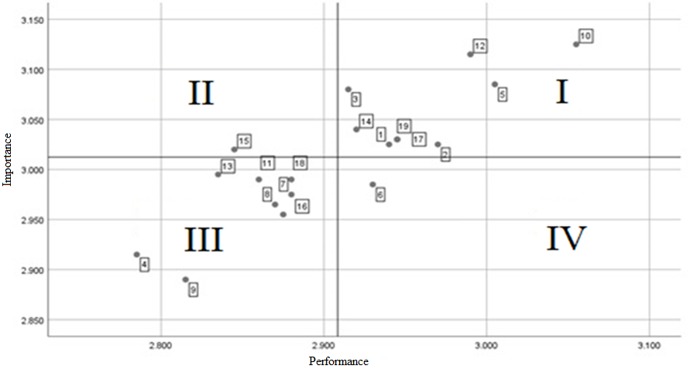

Fig 1 Importance Performance Analysis Quadrant Tribunnews’s Website

Based on Figure 1 it can be seen that there is 1 indicator in quadrant II, indicator number 15 regarding "Trust in information storage" which is a priority for improvement because users' expectations of these attributes are high whereas the reality is not in line with the expectations of its users. While in quadrant I there are 9 attributes, which means that these qualities must be maintained because they meet consumer expectations. While in quadrant III there are 8 attributes that show that this attribute does not really need attention because the user's expectations of this attribute are low. And the last in quadrant IV there is 1 attribute that shows this attribute is considered not too important but has good quality, so that attention to these attributes can be diverted to other attributes that are more in need.

- Importance Performance Analysis in Detik’s Website
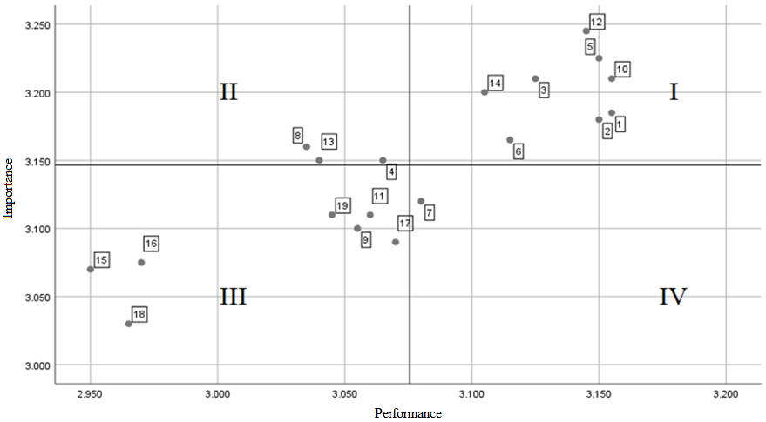
Fig 2 Importance Performance Analysis Quadrant Detik’s Website

Based on Figure 2, it can be seen that there are 3 attributes in quadrant II, namely indicator number 4 on "Attractive design", number 8 on "accurate information" and number 13 on "Detailed or detailed information" on attributes that are higher than expected in accordance with the expectations of its users. While in the quadrant, I consist of 8 attributes, which means attributes that must have quality because it meets consumer expectations. While in quadrant III contains 7 attributes that indicate this attribute does not need attention because user expectations of this attribute are low. And finally in quadrant IV including 1 attribute that shows this attribute is considered not important but has good quality, so that attention to this attribute can be transferred to other attributes that are more in need.

- Importance Performance Analys in Kompas’s Website

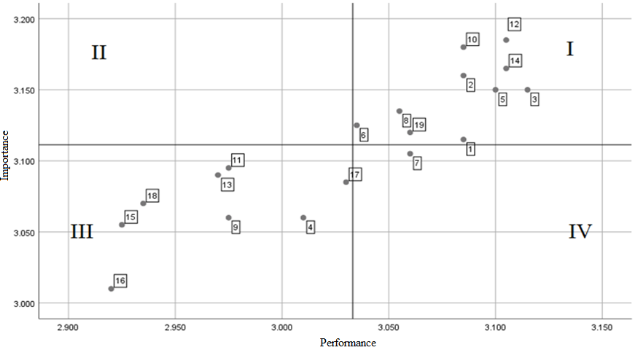

Fig 3 Importance Performance Analysis Quadrant Kompas’s Website

Based on Figure 3, it can be seen that there are no attributes in quadrant II, meaning that there is no priority for improvement because the performance of the Kompas’s website is in accordance with the expectations of its users. Whereas in quadrant I, there are 10 attributes, which means the quality must be maintained because they meet consumer expectations. While in quadrant III there are 8 attributes that show that this attribute does not really need attention because the user's expectations of this attribute are low. And the last in quadrant IV there is 1 attribute that shows this attribute is considered not too important but has good quality, so that attention to these attributes can be diverted to other attributes that are more in need.

Discussion

- How does each dimension of WebQual 4.0 affect the Tribunnews, Detik and Kompas websites?
The quality of the three Tribunnews, Detik and Kompas news websites has a strong or good category. This is shown based on the percentage generated from the analysis of the value of R on the three websites having values above 60% and less than 80% (60% <B <80%)
- How are the results of the quality analysis of the Tribunnews, Detik and Kompas website using the WebQual 4.0 method?
The gap values obtained from the three websites are negative on all indicators. This shows that the quality of the three websites does not meet the expectations of its users.
- Is the performance of the Tribunnews, Detik and Kompas websites in accordance with user expectations?
Overall all indicators need improvement, but there are some indicators that require special attention, namely indicators regarding "Trust in information storage" (Tribunnews) and indicators regarding "Attractive design", "Accurate information" and "Detailed information" (Detik).

Conclusion

The conclusion is that a popular or most frequently visited website according to similarweb.com is not directly proportional to the users' expectations of the three websites. Because it has a negative value gap between website performance and user expectations obtained through gap analysis. It is hoped that the Tribunnews website can further enhance security in the user's information storage section so that users feel more secure when using the Tribunnews website. Meanwhile, Detik's website can make improvements to the appearance of the website so that it has a more attractive design, and provides more accurate and detailed information when providing news.

References

[1] Adi, Suroto. 2015. Gap Analysis. URL: https://sis.binus.ac.id/2015/07/28/gap-analysis-analysis-kes gap/. Accessed July 30th, 2019.
[2] Barnes, S., & Vidgen, R. “Measuring website quality improvements: a case Ssudy of the forum on strategic management knowledge exchange”. Industrial Management & Data System. Vol. 103 Iss 5, 297 – 309, 2003.
[3] Barus, Ernesto Ersada, Suprapto dan Admaja Dwi Herlambang. 2018. “Analisis Kualitas Website Tribunnews.com Menggunakan Metode Webqual dan Importance Performance Analysis”. Jurnal Pengembangan Teknologi Informasi dan Ilmu Komputer. Vol 2. No. 4.
[4] Guritno, S. E. “Theory and application of IT research (Metodologi Penelitian Teknologi Informasi)”. Yogyakarta: Andi Offset. 2011.
[5] Kottler, Philip and Kevin Lane Keller. “Marketing management (13th Edition)”. Prantice Hall International. 2009.
[6] Pullinger, D. dan Bailin, A. “Reporting on Progress: Central Government Website 2009/2010”. Central Office of Information. London. 2010.
[7] Rahmaini, Safira Nur. “Analisis Kualitas Website Akademik Menggunakan Metode WebQual 4.0 dan Importance-Performance Analysis (IPA)”. 2018.
[8] Sanjaya, Imam. 2012. “Pengukuran Kualitas Layanan Website Kementerian Kominfo Dengan Menggunakan Metode WebQual 4.0”. Jurnal Penelitian IPTEK-KOM. Vol. 14. No. 1.
[9] Shia, B. C., Mingchih Chen, Agus David Ramdansyah, & Shuyan Wang. “Measuring customer satisfaction toward localization website by WebQual and Importance Performance Analysis (Case Study on AliexPress Site in Indonesia)”. American Journal of Industrial and Business Management, 117-128. 2016.
[10] Supranto, J. “Pengukuran Tingkat Kepuasan Pelanggan”. Jakarta : PT. Asdi Mahastya. 2011.
[11] Tarigan, J. “User satisfication using WebQual instrument : a research on stock exchange of Thailand (SET)”. Jurnal Akuntansi dan Keuangan. Vol. 10 No. 1. 2008.
[12] Wahyuni, Noor. 2014. “Gap Analysis”. URL: https://sis.binus.ac.id/2015/07/28/gap-analysis-analisa-kesenjangan/. Accessed July 30th, 2019.
[13] Yodi. 2018. “Analisis Kualitas Situs Web Batampos Menggunakan Metode WebQual 4.0”. Jurnal Rekayasa Sistem dan Teknologi Informasi. Vol. 2. No. 2.

